**XML**

Use Geolocation API service  
You can find the documentation for this API at <https://www.geoplugin.com/webservices/xml>

Check out the documentation to see how to use this API

Create a function which is sending request via AJAX and getting data in **XML** format

When data is received from the server, extract country name which is detected based on IP address, and show it on the screen.

**Extra:**

There is a button and input field on HTML page!  
Each time user clicks the button, function for getting geolocation data is invoked and new ip address written in input field is used when sending request.

**JSON**

Use Dog API

You can find the documentation for this API at <https://dog.ceo/dog-api/>

Check out the documentation to see how to use this API

Create a function which is sending request via AJAX and getting data in **JSON** format

When data is received from the server, extract image url, and use that url to create image element and add it to html page.

There is a button on HTML page!  
Each time when user click the button this function for getting image data is invoked and new picture is added to the page.

**GitHubSearcher**

Create a page that contains a logo and a search box (as shown on the mock)

The page is initially empty (there are no listed users)

The user can input some text in the search box

When the user clicks enter, a request is sent using jQuery Ajax API

The request is sent to GitHub’s endpoint for searching users

Documentation can be found at <https://developer.github.com/v3>

Try to find URL and structure of a request for searching users

When a response is received, print an image and a username on the page for all the users in the response

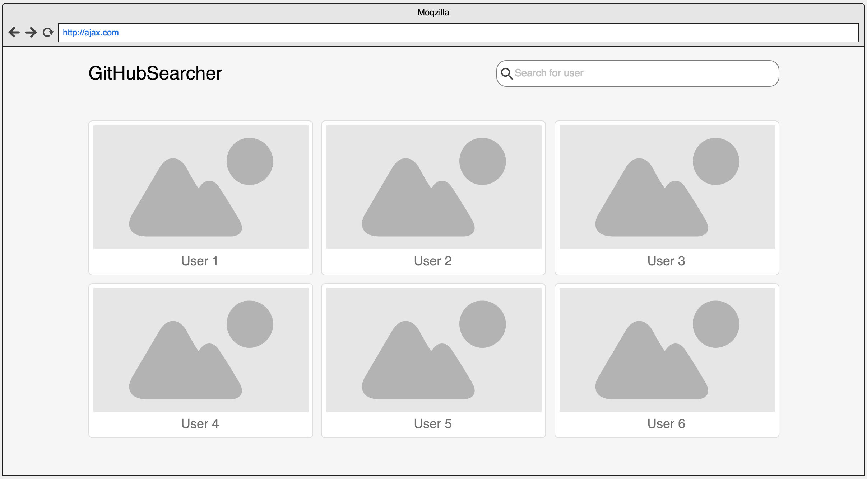

**Part II**

Build upon previous part of exercise (GitHubSearcher) and add additional features.

Each user in the list is clickable.

When user clicked new content (or new page) is presented.

Show all github repositories of selected user (in list of grid).

When showing repository you should present:

* Repository name
* Repository image, or some placeholder if there is no picture
* Description
* Number of start

API documentation for GitHub repositories: <https://developer.github.com/v3/repos/>

Extra:

For each repository show used languages on that repository